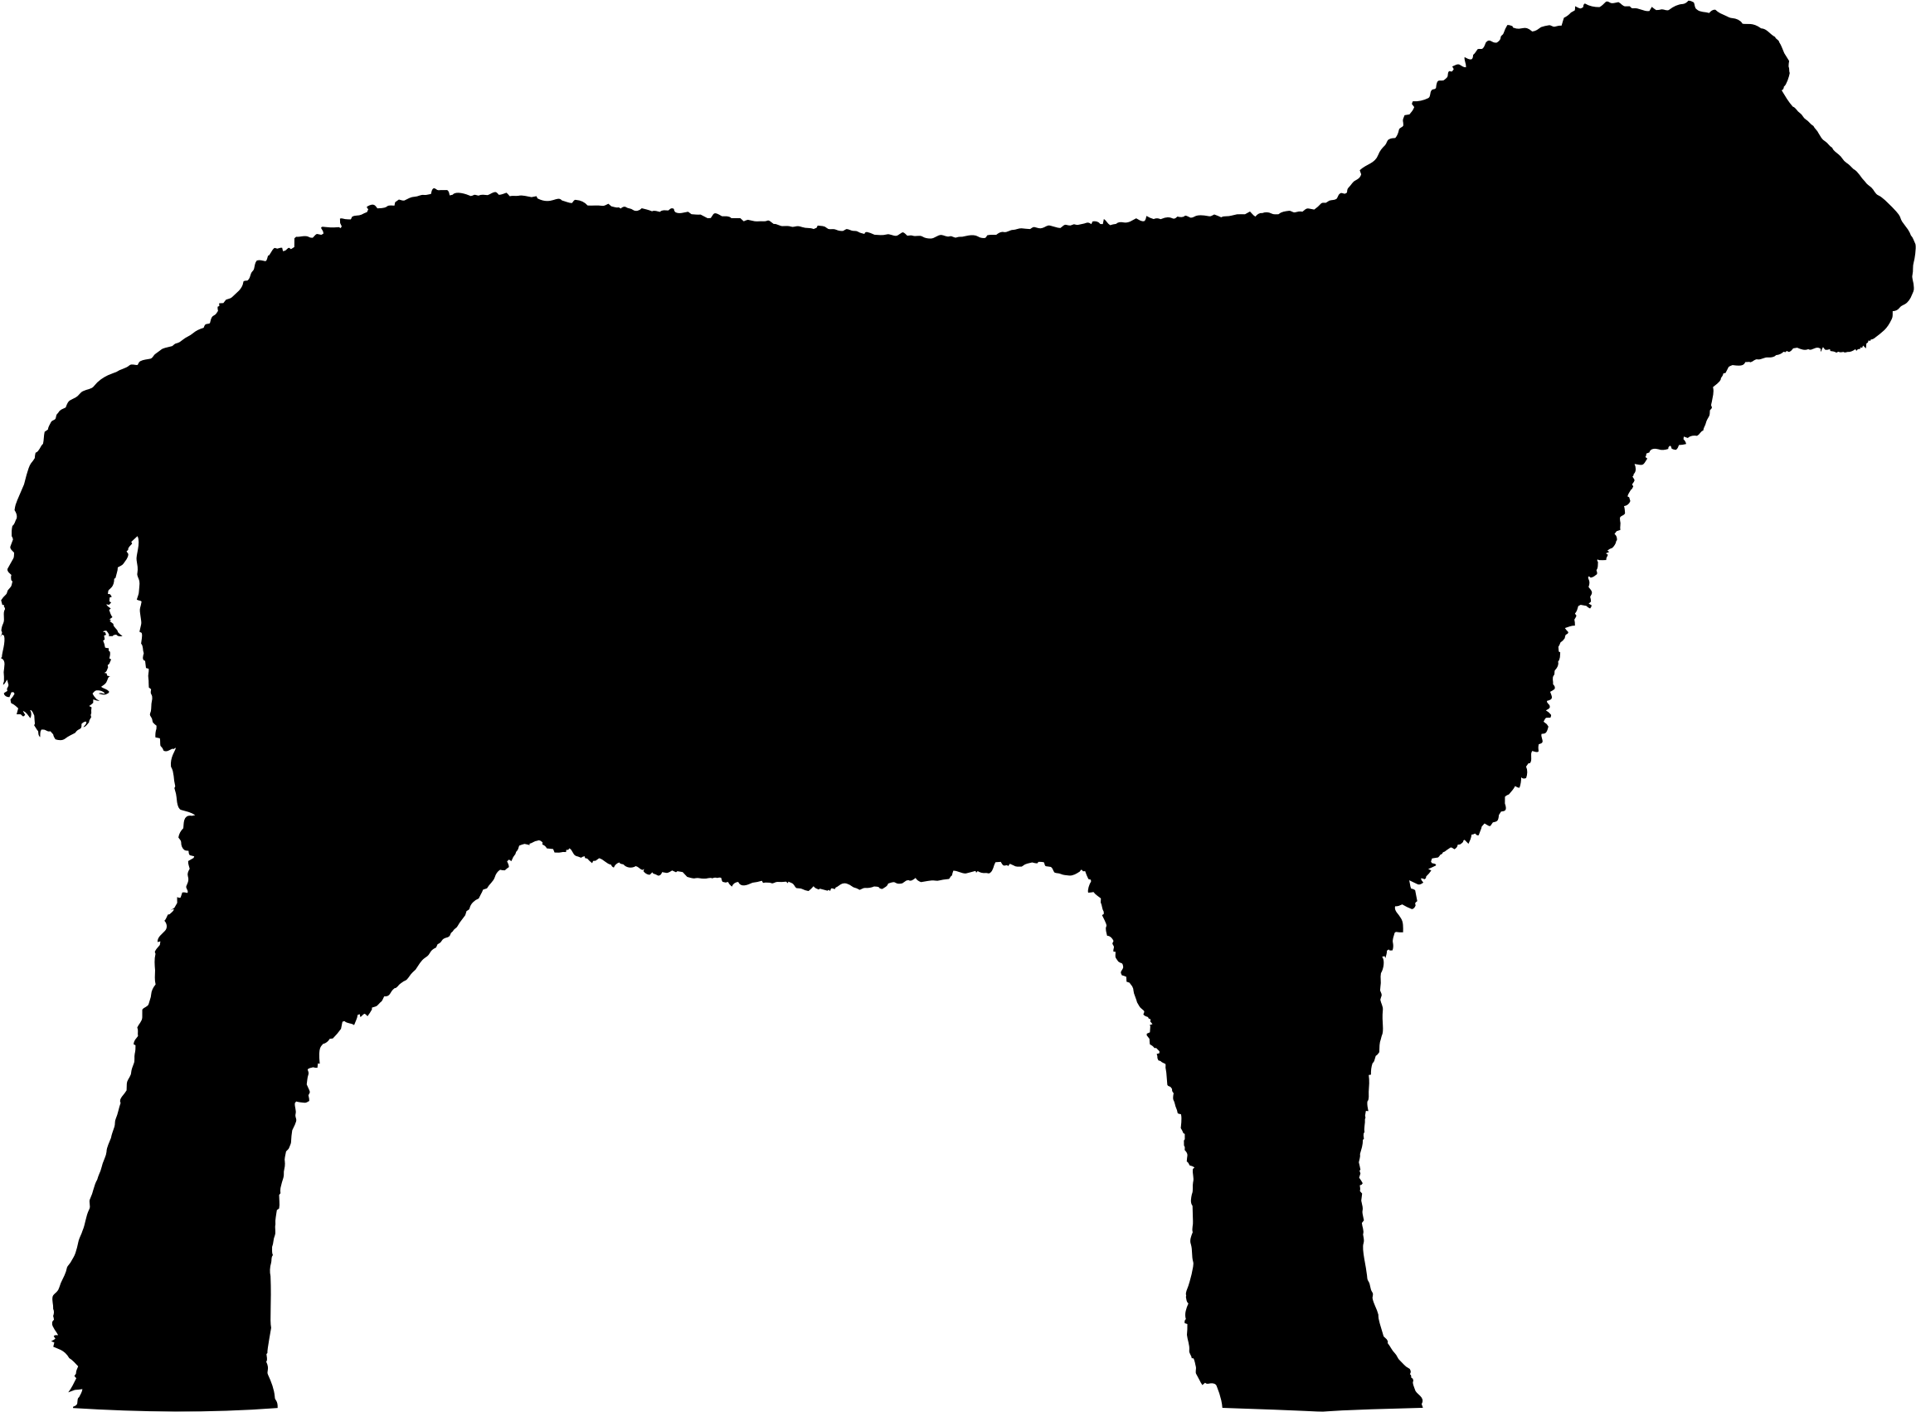Producer _________________

No. of Animals ______

_____ of _____

Lamb Cut Sheet

Date ____________

***CHOPS***

Chop Thickness _______ INCHES Chops Per Package _______ Roast Size _______ LBS

Name as appears on Label______________________________ Phone Number________________________

Tag Number ________ USDA ☐ ( $160 Flat Rate ) CUSTOM ☐ ( $135 FLAT RATE ) WHOLE HALF

City, State________________________

Live Weight ________ Hang Weight ________

***Extras***

☐ Heart ☐ Liver ☐ Stew Meat

***SHANKS***

☐ Whole ☐ Ground

***NECK***

☐ Roast ☐ Sliced ☐ Ground

***RIB***

☐ Whole Rack ☐ Half Rack ☐ Bone-in Chops ☐ French style rib chop ☐ French style rib roast

***DENVER RIB***

☐ Whole ☐ Ground

***LOIN***

☐ Bone-In Chops ☐ Bone-In Roast ☐ Boneless Roast ☐ Ground

***SHOULDERS***

☐ Bone-In Roast ☐ Boneless Roast ☐ Bone-In Chops ☐ Ground

***LEGS***

☐ Bone-In Steaks ☐ Boneless Roast ☐ Bone-In Roast ( Leg of Lamb ) ☐ Boneless Roast with net

☐ Butterfly Roast without net ☐ Ground