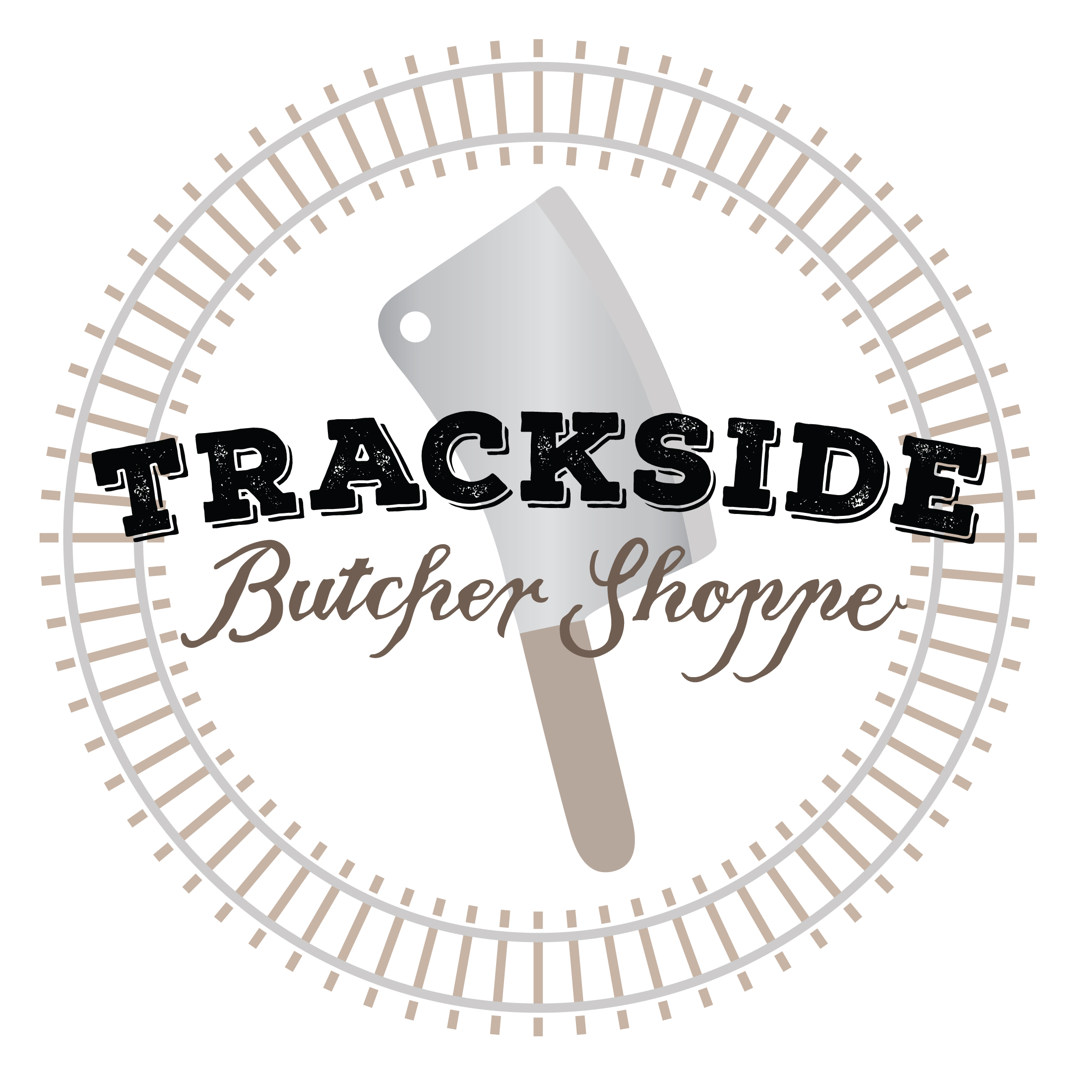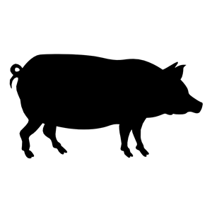Producer _________________

No. of Animals ______

_____ of _____

HOG CUT SHEET

Date ____________

Name ___________________________ City, State ________________________ Phone Number ________________________

Tag Number _________ WHOLE HALF Picked up by __________________________

* USDA ($60 kill fee, $0.96 per pound hanging weight)
* Custom ($45 kill fee, $0.90 per pound hanging weight)

Live Weight ________ Hang Weight ________

***JOWL***

☐ Fresh- Sliced or Whole ☐ Cured & Smoked ($1.49/lb) – Sliced or Whole ☐ Ground

***BELLY (BACON)***

☐ Fresh – Sliced or Whole ☐ Cured & Smoked ($1.49/lb) – Sliced or Whole ☐ Ground

***HAM***

☐ Fresh – Whole or Roast ☐ Cured & Smoked ($1.49/lb) – Sliced ($10) or Whole ☐ Ground

***CHOPS***

☐ Boneless (TENDERLOIN – Sliced or Whole) ☐ Bone-In ***CHOP THICKNESS*** _______ INCHES

***CHOPS PER PACKAGE*** _______

***ORGAN MEAT***

☐ Heart ☐ Neck Bones ☐ Liver ☐ Fat

***GROUND/SAUSAGE*** Choose One, Any additional choices are a $15 fee each, Sausage comes in 25lb increments

☐ No Spices ☐ Mild ☐ Medium ☐ Hot ☐ Extra Hot ☐ Extra Sage ☐ Maple ☐ Chorizo ☐Italian

***HOCKS***

☐ Fresh ☐ Ground

***BOSTON BUTT***

☐ Whole ☐ Roast ______lbs ☐ Ground

***RIBS***

☐ Whole ☐ Half ☐ Ground

***PICNIC HAM***

☐ Fresh – Whole or Roast ☐ Cured & Smoked ($1.49/lb) – Sliced or Whole ☐ Ground